Data flow :

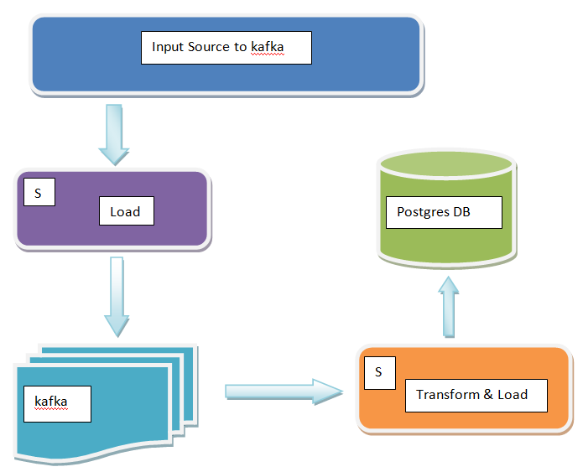

**S ==> Spark/scala jobs**

**Load : spark job reads data from file and loads into kafka topic.**

**Transform and load : Spark job apply transformations and filtering on the data and persist output dataset into postgresdb.**

**==> input source to kafka file's from testdata directory location**